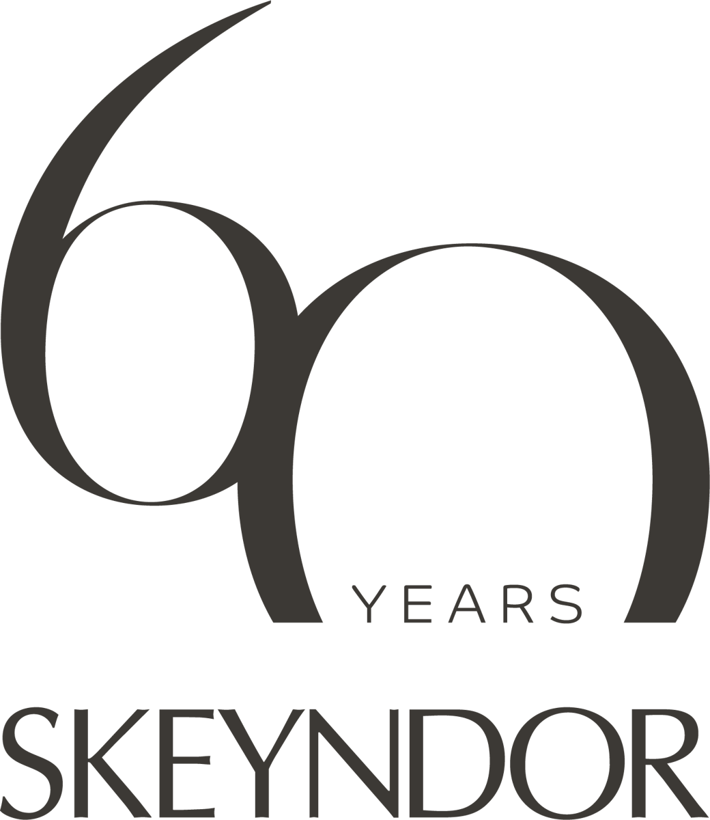
PRESS RELEASE · FOR IMMEDIATE RELEASE
SKEYNDOR turns sixty. The Spanish professional skincare house celebrated in Tenerife with more than 1,200 beauty professionals, and the next chapter is arriving in Australia.
Founded in 1966, SKEYNDOR marked its 60th anniversary at The Ritz-Carlton Tenerife, Abama, in September 2026. Six days of celebration, one documentary premiere, an artificial intelligence as host, a longevity lecture by a leading dermatologist, and two new professional innovations. SKEYNDOR’s Australian distributor was in the room. Here is what it means for Australian salons and clinics.
Melbourne, October 2026. There are anniversaries that are celebrated, and anniversaries that are lived. SKEYNDOR chose Tenerife to commemorate its 60-year history, bringing together more than 1,200 clients and beauty professionals from across Spain and around the world. Under the concept 60 years ahead of our time. Behind every story, the week was conceived as a tribute to the people behind six decades of professional beauty: therapists, clinic owners, distributors and the company’s own teams, with the brand now present in more than 60 countries.
“If this story is celebrating sixty years today, it is not because my family founded a company. It is because thousands of you decided to walk alongside us,” said Jordi Morcillo, CEO of SKEYNDOR, during the celebration. “When I look around this room, I don’t see clients, I don’t see distributors, I don’t see employees. I see people. I see friends. I see a family.”
The programme matched the occasion. The Sunset Party by Moët & Chandon on the Abama terraces, with the Atlantic as its backdrop. The Golden Première Gala, hosted by Spanish television presenter Anne Igartiburu, with a four-act menu, Origin, Precision, Mastery and Emotion, created by Martín Berasategui, the chef with nine Michelin stars across his restaurants. And the premiere of Stories Behind the Story, a documentary in which members of the founding families, distributors and employees tell the company’s story in their own voices. Among the guests was Antonia Mur, a key figure in the company’s history and the link between its founding generation and the one leading it today.
A morning that looked forward. The anniversary presentation on 15 September was opened by SIA, SKEYNDOR’s own artificial intelligence, which introduced the speakers and narrated the treatment phases: a live demonstration of the house’s position that technology amplifies the professional rather than replacing her. Jordi Morcillo walked the room through the decades, from the first encapsulated actives of the 1980s to the seven shifts of the last ten years: digital, consumer empowerment, sustainability, artificial intelligence, personalisation, longevity and integrative beauty. His answer to how a company stays relevant for sixty years: you don’t stay relevant. You become relevant, again and again.
Dr Almudena Nuño, dermatologist and Vice-President of Communication at the Spanish Academy of Dermatology and Venereology, delivered the lecture on healthy longevity. Roughly a third of how skin ages is genetic. The rest is the exposome: sun, sleep, food, stress, pollution. Chronic low-grade inflammation is the engine, sugar stiffens collagen, strength training builds it, and a repaired skin barrier lowers inflammation markers in the blood. Her conclusion for the treatment room: what a professional does on the face talks to the whole organism.
International marketing manager Laura Cita set out the six trends shaping the consumer of tomorrow: longevity, integrative beauty, the rise of science, medicalisation, personalisation and artificial intelligence. And the one that explains the professional channel in a sentence, the trust economy. She does not trust advertising, and she does not trust influencers she has never met. She trusts the professional who has cared for her skin for years.
Two launches. The event was the setting for two new product launches. The first, MICROSPICULE MATRIX PHX, was unveiled on stage as the next era of biological skin activation: a professional, non-invasive method inspired by mesotherapy and powered by microspicule technology, carrying a regenerative activation matrix of PDRN, hyaluronic acid and NAD+ into the skin. It will reach Australia in 2027, with professional partners trained first. The second launch remains under embargo until its international launch in early 2027.
Australia. SKEYNDOR has been represented in Australia by Vogue Image Group, the Melbourne family business led by CEO Luca Mora, for more than two decades. “Tenerife showed us exactly where the brand is going, and Australia is ready for it,” said Luca Mora. “Sixty years on, SKEYNDOR is still a family company that makes its own formulas in its own laboratory, and it is moving toward the clinic: longevity, regenerative science, and protocols that join the treatment room to home care. That is the direction our salons and clinics have been asking for.”
The first of that next chapter is already here. CLEARIST CTX, SKEYNDOR’s professional range for oily, congested and acne-prone skin, began rolling out to Australian salons and clinics in October 2026. SKEYNDOR’s first line to approach oily and acne-prone skin from aesthetic medicine and psychodermatology together, it pairs a five-step home routine with a 60-minute professional treatment delivered under blue and red light with the DERMALED XPERT device. In SKEYNDOR’s usage test of the complete protocol, sebaceous gland activity fell by 73%, inflammatory lesions by 63% and comedones by 42%, with visible results in 35 days.*
ENDS
* Use test under dermatological and ophthalmological control, 21 volunteers aged 18 to 55 with acne-prone combination or oily skin, five weeks of home care plus two professional treatments with DERMALED XPERT. Results belong to the complete protocol, not to individual products.
Media contact
Luca Mora, Chief Executive Officer, Skeyndor Australia · Vogue Image Group
luca@vogueimage.com.au · (03) 9821 0033 · 45 John Street, Oakleigh VIC 3166
Imagery
36 high-resolution photographs from the Madrid press lunch (20 May 2026) and the Tenerife celebration (14 to 17 September 2026), plus product imagery for CLEARIST CTX and MICROSPICULE MATRIX PHX, are supplied with this release with a caption sheet. All images © SKEYNDOR, cleared for editorial use with credit. The official 60th anniversary documentary, Stories Behind the Story, is on SKEYNDOR’s YouTube channel.
Notes to editors
Media treatments of CLEARIST CTX with DERMALED XPERT can be arranged in Melbourne and Sydney. Product samples of the CLEARIST CTX home-care range are available on request. Interview requests for Luca Mora, and for SKEYNDOR’s international team, via the media contact above.
About SKEYNDOR
SKEYNDOR is a globally recognised professional skincare brand renowned for its commitment to scientific research, innovation and advanced cosmetic solutions. Founded in 1966 in Terrassa, Spain, and now present in more than 60 countries, the company offers an extensive portfolio spanning hydration, anti-ageing, body care and makeup, with anti-ageing expertise at the heart of the brand. For six decades SKEYNDOR has remained at the forefront of professional skincare through continuous research into new actives, ongoing technological innovation and the expertise of its specialist teams, driven by one philosophy: Science Creates Beauty. skeyndor.com
About Skeyndor Australia
Vogue Image Group is the exclusive distributor of SKEYNDOR in Australia and New Zealand, supplying professional salons, clinics and spas with the full SKEYNDOR professional and home-care portfolio, the MEGAN and DERMALED XPERT devices, and accredited training. A Melbourne family business, Vogue Image Group has represented SKEYNDOR for more than two decades. Consumers: skeyndor.au · Professionals: pro.skeyndor.com.au

